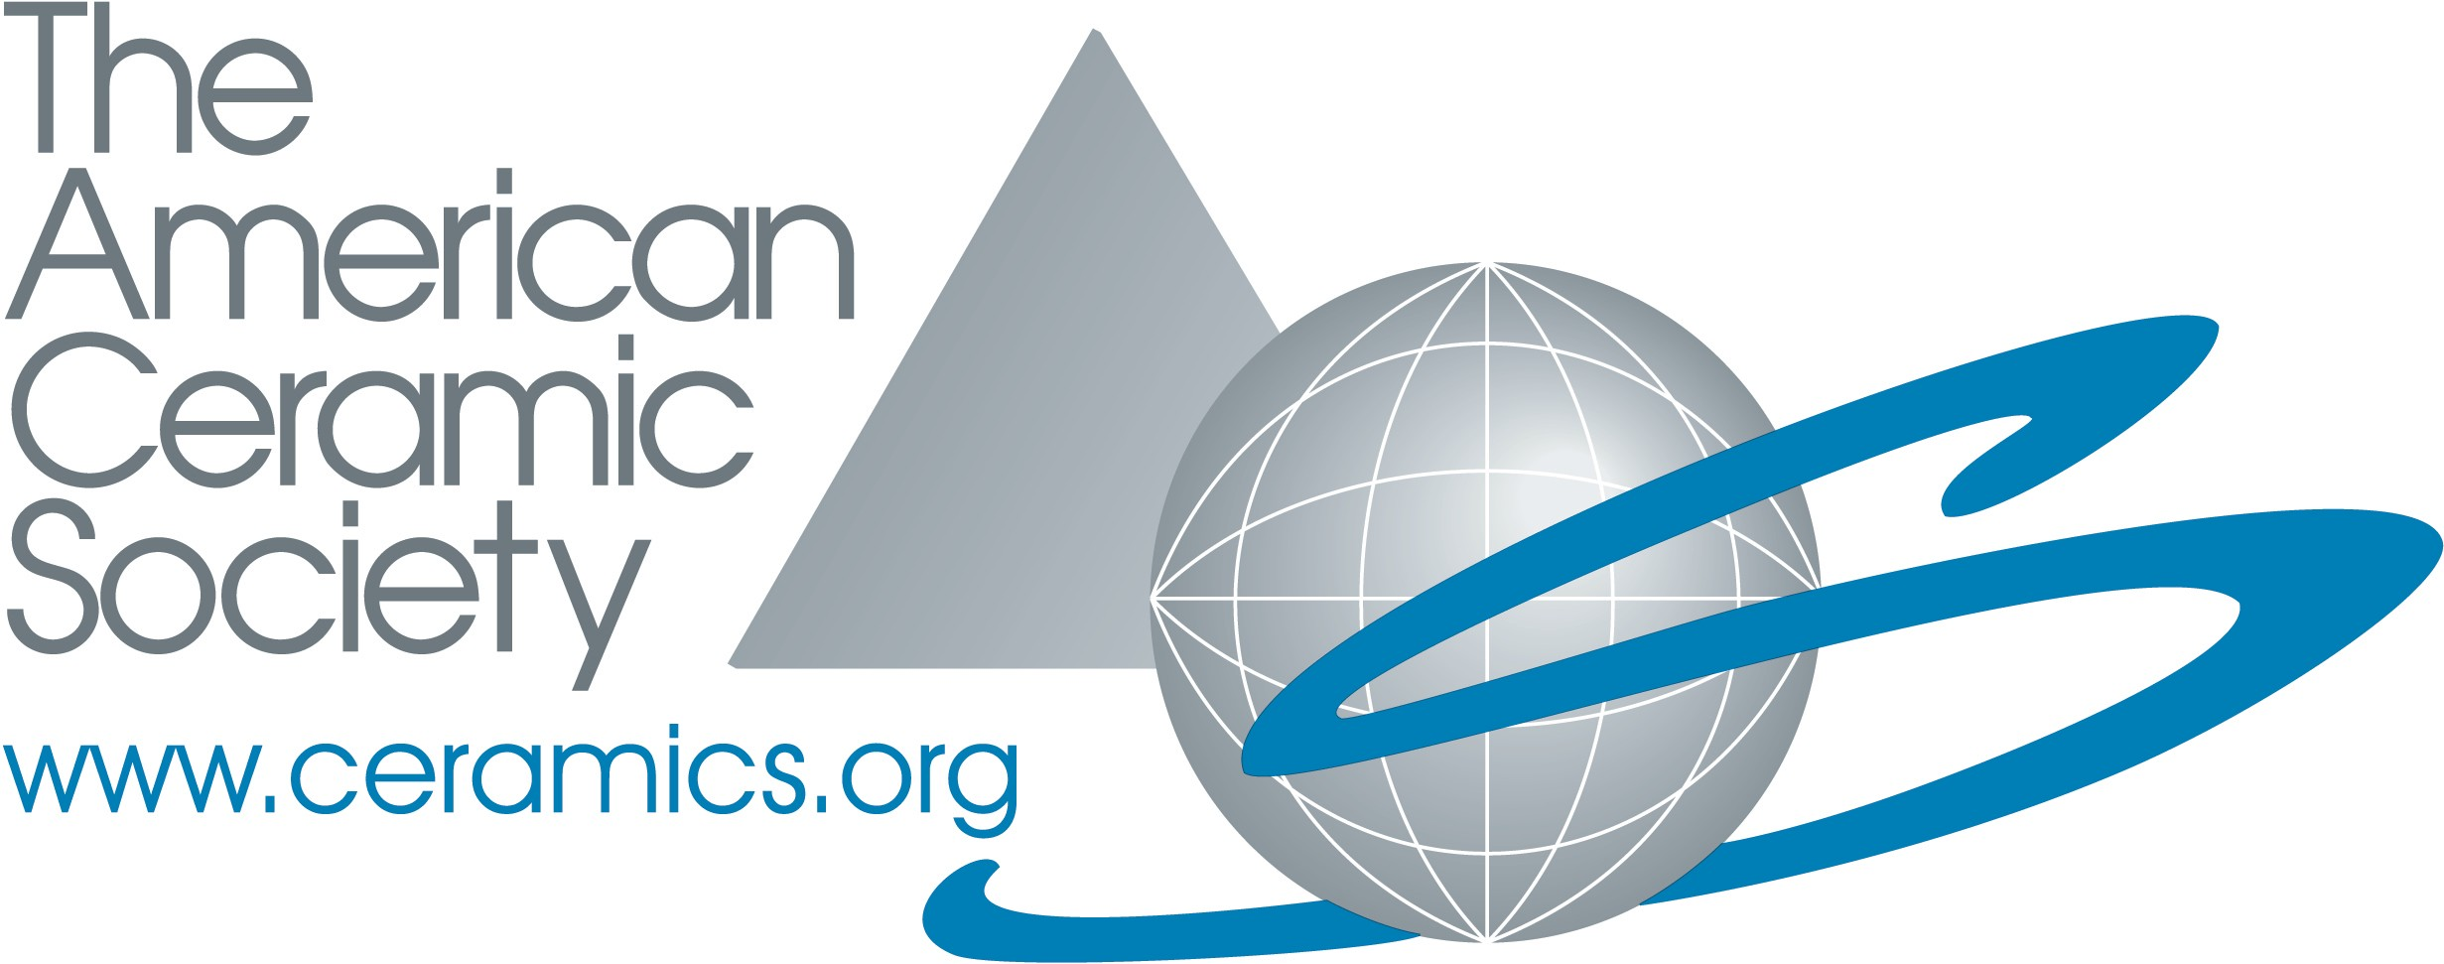

The American Ceramic Society
Global Ambassador Nomination Form

Name of nominee: Address:

Phone: Fax: Email:
Current ACerS member: Yes No

Name of nominator (if different than nominee): Address:

Phone: Fax: Email:
Current ACerS member: Yes No Signature:
Date:

Submit a statement of no more than 500 words stating the nominee’s leadership and service to ACerS either over a period of several years, or highlighting service over and above expectations in a single event/activity, such as organizing a meeting, chairing a committee or task force, recruiting new members, frequently writing and/or reviewing for ACerS publications, or tirelessly promoting the Society and the ceramics and glass community to the rest of the world.

Complete the nominee statement on the next page, and return it and this page to:

Erica Zimmerman
The American Ceramic Society 600 N. Cleveland Ave., #210
Westerville, OH 43082

Electronic nominations are preferred. Send to ezimmerman@ceramics.org.

The American Ceramic Society
Global Ambassador Nomination Form

Name of nominee:

