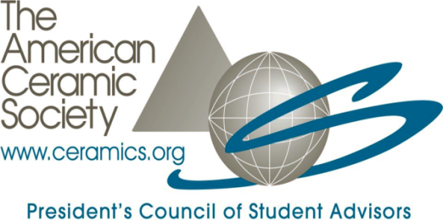

Applicant Information
Full Name: |  | Click here to enter text. |  |  |  |  | Click here to enter text. |  | Click here to enter text.
Last |  |  |  |  |  |  | First |  | M.I.
Mailing Address: |  | Click here to enter text. |  |  |  |  |  |  | Click here to enter text.
 |  | Street Address |  |  |  |  |  |  | Apartment/Unit #
 |  | Click here to enter text. |  |  |  |  |  | Click here to enter text. | Click here to enter text.
 |  | City |  |  |  |  |  | State/Country | ZIP/Postal Code
Preferred Phone: |  |  | Click here to enter text. |  |  | Preferred Email: | Click here to enter text.
Expected graduation date: |  |  | Click here to enter text. |  |  | Major/degree you are pursuing: | Click here to enter text.
Are you an undergraduate or graduate student? |  |  |  |  | Click here to enter text.
University or Institution: |  |  |  |  | Click here to enter text.

Questions
Please answer the following questions to the best of your ability.
Yes | No | Unsure
 |  |  |  | Are you planning to attend MS&T 2013 if not selected as a PCSA delegate?
 |  |  |  | Are you willing to find other travel support (e.g. from your university, department, etc.) if PCSA cannot cover all of your travel costs to the annual meeting at MS&T 2013?
 |  |  |  | Are you a current delegate of PCSA?
 |  |  |  | Are you a current representative of PCSA?
 |  |  |  | Are you a student studying at a university outside of the U.S.?
 |  |  |  | Are you a Material Advantage Member? (Note: Material Advantage membership is required to be a PCSA delegate.)

Additional Application Information

Please submit this application to applypcsa@ceramics.org along with the following via email by June 7, 2013:
- Resume that clearly identifies your year in school and includes any leadership, research and employment experience
- Brief letter of support from a faculty member
- 1-page personal statement that addresses:
  - Your reasons for wanting to attend the PCSA meeting at MS&T’13 and why participation in PCSA will be valuable to you and your local university or department
  - Your interest in ceramics
  - Your academic or career plans for the near future (within 10 years)

For more details about PCSA and delegate duties, please visit the PCSA website: http://ceramics.org/pcsa.

Please note that MS&T 2013 will be held in Montreal, Canada. If selected as a PCSA delegate, it is your responsibility to make sure you have the proper documents to travel to Montreal in October. ACerS can provide a letter of support for students who are non-U.S./Canadian citizens and who require a Visa to attend the meeting in Canada; however, ACerS cannot guarantee procurement of a Visa. For U.S. citizens, you do not require a Visa, but you do need a U.S. Passport to cross the border into Canada.

