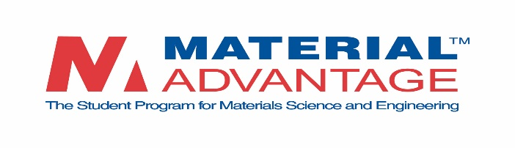

2018 Material Advantage
Congressional Visits Day (CVD)
April 17-18, 2018
REGISTRATION and TRAVEL GRANT APPLICATION*
*All participants must complete this registration form, including faculty advisors.
PLEASE RETURN THIS FORM BY March 9, 2018.

IMPORTANT NOTE: CVD is intended for students who reside in, or are attending schools in, the United States; therefore, we are only accepting applications from students who meet this criteria. CVD opportunities are best suited for US citizens and permanent residents; however, international students can participate if space is available. Students wishing to attend CVD must be Material Advantage members. Due to limited funds and space, a maximum of 5 students from any one university may request travel grants and attend the reception on the evening of April 17.

The Material Advantage Student Program is offering a limited number of travel grants to student registrants to help offset costs to Congressional Visits Day. The amount of travel grant funds will be determined once applications are received, but we expect it will be between $100 - $150 per person. All grants will be sent after the event upon verification that the student was in attendance. Faculty are not eligible for travel assistance at this time. Registration and travel grant applications are accepted on a first come, first served basis, so act early!

NAME:______________________________________________________________________________

UNIVERSITY:________________________________________________________________________

ADDRESS:___________________________________________________________________________

___________________________________________________________________________

CELL PHONE:__________________________ E-MAIL:____________________________________

(Please check one below)
_____ I am a Material Advantage Student Member.

_____ I am a Material Advantage Faculty Advisor.
For Student Members only:
Are you applying for a travel grant? Yes No If yes, will you be flying or driving? ____________

PLEASE RETURN THIS FORM BY March 9, 2018.

By Email: ynatividad@ceramics.org

By FAX: 614-794-5817

All travel and hotel reservations must be made on your own.

